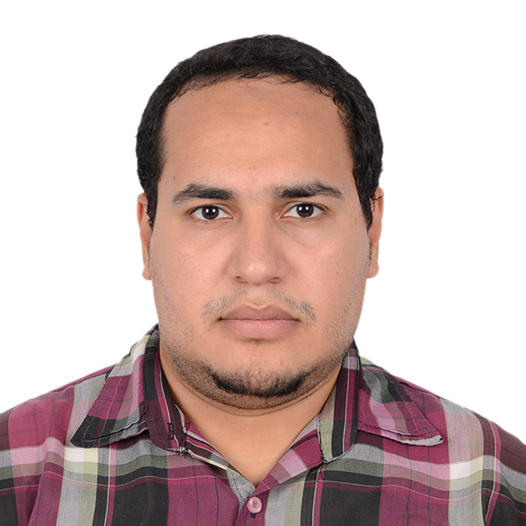PERSONAL INFORMATION |  | Mohamed Rabee Hamed Ahmed
 | Department of Cardiothoracic Surgery, Faculty of Medicine, Assiut UniversityAssiut ,Egypt.
 | +02(0102631721-01558701123)
 | mohamed.rabee.hamed@gmail.com
 | www.aun.edu.eg/arabic/membercv.php?M_ID=6775
SexMale|
Date of birth14/02/1992|
NationalityEgyptian

STUDIES APPLIED FOR | Cardiothoracic Surgery

WORK EXPERIENCE

November 2021-now  March 2017– September 2017  March 2016 –February2017 | Assistant lecturer cardiothoracic surgery  AssiutUniversity Heart Hospital, Assiut, Egypt.  Cardiothoracic Surgery Resident  AssiutUniversity Heart Hospital, Assiut, Egypt.  House Officer
 | Assiut University Hospital, Assiut, Egypt.
 | - I received training of 2 months in each of the following specialities: - Internal Medicine, General Surgery, Gynaecology and Obstetrics, Paediatrics, Emergency and Anaesthesia.

EDUCATION AND TRAINING
April 2018  March 2016 –February2017:  September 2007-December2013 : | Master of Science (M.Sc.) [ General Surgery]:  Faculty of Medicine, Assiut Univ. Hospital, Assiut, Egypt, Janury, 2018;very Good. Review article title" Comparison between interlocking multi-twisted wires & eight figure of sternum closure post open heart surgery "  House-officer,  Assiut Univ. Hospital, Assiut, Egypt  Medical Student,  Faculty of Medicine, Assiut Univ., Assiut, Egypt  Graduation: Bachelor’s Degree in Medicine and Surgery: Faculty of Medicine, Assiut Univ., Assiut, Egypt, September, 2015; Excellent with honor degree.

PERSONAL SKILLS

Clinical skills | During my work as a house officer, as a resident and as an assistant lecturer, I gained experience in the following activities:  - Out-patient clinical management,  - In-patient clinical management,  - Management of traumatized patients,  Emergency surgery: in the emergency unit of my department concerned with the reception of cases like all kinds of blunt thoracic trauma including fracture ribs, flail chest, traumatic haemo and Pneumothoacis, Penetrating traumas including firearms and stab wounds to the pericardium and thoracic cavity where most of the cases are managed by me as main surgeon or assisting more junior surgeons in the trauma unit in my university hospital.  Elective surgery, including: -  Thoracic surgery: - I acted as a main surgeon or assisted by a senior surgeon in rigid esophagoscopies, Rigid bronchoscopy, foreign body extraction, Thoracotomies, Decortications, Pulmonary resections including lobectomies and sgmentectomies,peumonectomies, mediatinal tumor excisions, chest wall resections and reconstruction, diaphragmatic hernia repair and Tracheo esophageal fistula repair.  Cardiac Surgery: - I acted as a main surgeon or assisted by a senior surgeon Opening and closure of sternotomies, Aortobicaval cannulation, femoral cannulation, Saphenous vein graft, radial arteryand left internal mammary harvesting, Secondom atrial septal defects closure, and aortic, mitral valve replacement..  I assisted a more senior surgeon in CABG either on pump or Off pump, mitral and aortic valve replacements, minimally invasive mitral valve replacement, minimally invasive ASDclosure minimally invasive aortic valve replacement , minimally invasive tricuspid valve replacement, ,ascending aortic and aortic root replacement, pericardiecomy for constrictive pericarditis, and an array of congenital cardiac surgeries including ASD and VSD closure, Tetralogy of Fallot repair, coarctaion of the aorta, PDA ligation , single ventricle repair (both stages), partial and complete A-V canal repair , repair of coarctaion o aorta , repair of coronary artery dilatation .

Computer skills  Other skills | Good command of Microsoft Office™ tools.  -Since we do not have a school for perfusionists in Egypt so most of surgeons including me have good command of cardiopulmonary bypass.  -I successfully completed the cognitive and skills evaluation in accordance with the curriculum of the American Heart Association Advanced cardiovascular Life Support.  - I take a lot of training courses as:  *Infection control April 2016  *Ethical ,law and Administrative Consideration In Medical Practice  *Attendance Cardio Alex 2018  *EBAC CERTIICATE O ATTENDANCE or Cardio-Alex18 participation  *Training Set CERTIICATE ECHO MITRAL PROLAPSE  *Writing Medical Reports July 2020  *Infection control in July 2020  *Evidence Based Medicine in July 2020  *How To Write Research Protocol in July 2020  *Based Cardio- Pulmonary Resuscitation in July 2020  *Attendance 4TH ,5TH,8TH, Video Assisted Thoracoscopic surgery  *Attendance of Chest Ultrasound For Thoracic Surgeon February 2022  *الدوره السابعة والستين لاعداد المعلم الجامعي لشهر اغسطس 2022

Publications | MohammedRabeeHamed*, Ali Abedl Wahab, Ahmed M. Taha, Mohamed Sawat .  " Comparison between interlocking multi-twisted wires & eight figure of sternum closure post open heart surgery "  Faculty of Medicine, Cardiothoracic Surgery Department, Assiut University Heart Hospital, Assiut, Egypt.

N.B: All Certificates are available on demand
Thank you for the precious time spent reviewing this resume.I will have pleasure to be a member of your research team.

